Step 1: Open your browser ex. Google Chrome or Edge
Step 2: Search for office.com
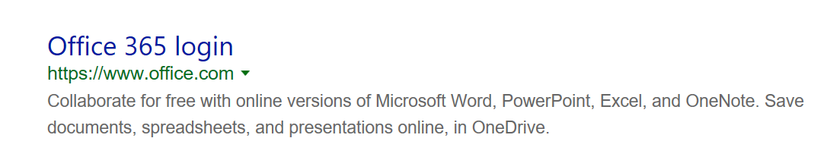
Step 3: Sign in with your computer login@nfschools.net (ex. Mjones@nfschools.net)
Password is your computer password.
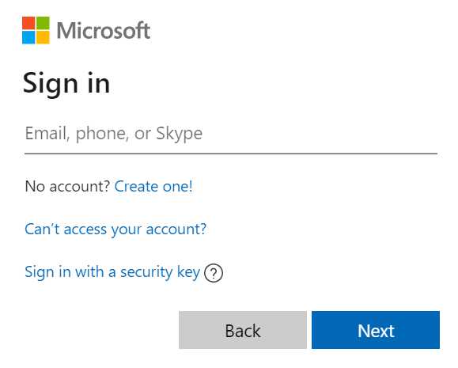
If your username or password does not work please reach out to: mcacciatore@nfschools.net
Step 4: Your screen should look like this
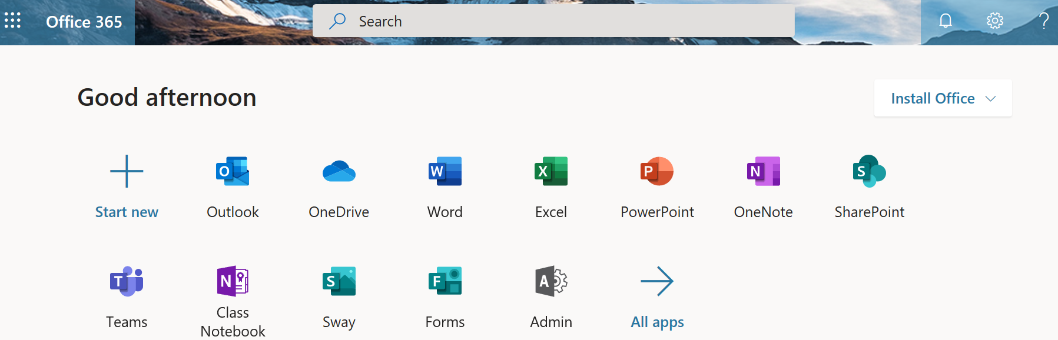
Step 5: Click on the Teams App. This will open your list of class Teams. Select a Team to view class Files and Assignments. IF the teacher adds an assignment please use the Turn In button to submit your work. 😊

